6/15/2026
Sharam
[company name]
Tech Company Management System

Group members:
Muhammad Shahram(sp25-bcs-025)

Section: A

Submitted to: Mam Mamoona Alaam
📌 Database Project Report: Tech Company Management System

1. Scenario
A tech company requires a robust database system to manage its day-to-day operations, including employee management, department allocation, client projects, and task assignments.Every day, clients request different tech solutions like "Website Development". The company registers clients and manages projects with specific budgets, statuses (eg, "Completed", "Pending"), and timelines.
The company has multiple departments (eg, "CS" - Computer Science).Employees are hired and assigned to these departments with specific roles (eg, HR, Frontend Developer).Since a single project requires multiple employees, and one employee can work on multiple projects simultaneously, the company uses an Assignments system to track which employee is working on which project, their specific role, and the hours allocated to them.

2. Assumptions
To simplify the database design, the following assumptions are made:
- Each employee can belong to only one department at a time.
- Each project is assigned to only one client.
- An employee can work on multiple projects at the same time.
- A project can have multiple employees working on it.
- System audit fields likeCreatedAt and UpdatedAtare tracked for all major records.
- The system tracks work assignments, specifically the role and allocated hours for each employee per project.

3. Entities (Identities)
Based on the database schema, the following entities are identified:
- Departments
- Employees
- Clients
- Projects
- Assignments (Bridge Entity for Many-to-Many Relationship)

4. Attributes

- Departments: DeptID (Primary Key), DeptName, Location, CreatedAt, UpdatedAt.
- Employees: EmpID (Primary Key), FirstName, LastName, Email, Phone, Salary, HireDate, DeptID (Foreign Key), Position, CreatedAt, UpdatedAt.
- Clients: ClientID (Primary Key), ClientName, ContactInfo, CreatedAt, UpdatedAt.
- Projects: ProjectID (Primary Key), ProjectName, Description, StartDate, EndDate, Budget, Status, ClientID (Foreign Key), CreatedAt, UpdatedAt.
- Assignments (Bridge Table): AssignmentID (Primary Key), EmpID (Foreign Key), ProjectID (Foreign Key), Role, HoursAllocated, AssignedDate.

5. Relationships
- One Department → Many Employees (1:M): One department (eg, CS) can have multiple employees, but one employee belongs to one department.
- One Client → Many Projects (1:M): A single client can give multiple projects to the company.
- Employees ↔ Projects (M:N): Many employees can work on many projects.This is resolved using the Assignments table.

6. Many-to-Many Relationship Resolution
A many-to-many relationship exists between EmployeesandProjects.
- Example: Employee "Ali Farooq" can work on "Website Development" and "Mobile App", while the "Website Development" project includes both "Ali" and "Ahmed".
- Resolution: This is resolved by creating the Assignments table, which holds the Foreign Keys of both Employees(EmpID) and Projects(ProjectID), along with assignment-specific details like Role(eg, front end dev) and HoursAllocated(eg, 24 hours).

7. Business Rules
- Each employee must have a unique EmpID.
- An employee's salary and position (eg, HR) must be recorded.
- Projects must have a defined Budget (eg, 10000.00) and Status (eg, Completed).
- Assignmentstrack exactly how many hours an employee is assigned to a specific project.

8. User Story
- As an HR Admin , I want to manage employee records (name, salary, department) so that payroll and department allocations are accurate.
- As a Project Manager , I want to assign employees to specific projects and allocate working hours so that project delivery is smooth.
- As a Management Executive , I want to view the status and budget of projects to ensure they are completed on time and within cost.

9. Normalization
The database is fully normalized to ensure data integrity and reduce redundancy:
- 1NF (First Normal Form): All tables have atomic values. There are no repeating groups.For instance, FirstNameand LastNameare separate columns.
- 2NF (Second Normal Form): The database is in 1NF, and all non-key attributes fully depend on the primary key.Bridge table Assignmentsuses AssignmentIDas a primary key, preventing partial dependency.
- 3NF (Third Normal Form): The database is in 2NF, and no transitive dependencies exist.For example, Department details ( DeptName) are stored in the Departmentstable, not in the Employeestable, linking them viaDeptID.

10. Database Operations (CRUD - SQL Queries)
Here is the practical working of the database with the 4 basic functions (Create, Read, Update, Delete) based on your exact data.
1. CREATE (Insert Data)
SQL
-- Adding a new Department
INSERT INTO dbo.Departments (DeptID, DeptName, CreatedAt, UpdatedAt)
VALUES (2, 'cs', GETDATE(), GETDATE());

-- Adding a new Employee
INSERT INTO dbo.Employees (EmpID, FirstName, LastName, Email, Phone, Salary, DeptID, Position)
VALUES (1, 'Ali', 'Farooq', 'ali@gmail.com', '030876272', 5000.00, 2, 'Hr');
2. READ / VIEW (Retrieve Data)
SQL
-- View all completed projects
SELECT ProjectName, Budget, Status
FROM dbo.Projects
WHERE Status = 'Completed';

-- View Employee Assignments with specific details
SELECT e.FirstName, p.ProjectName, a.Role, a.HoursAllocated
FROM dbo.Assignments a
JOIN dbo.Employees e ON a.EmpID = e.EmpID
JOIN dbo.Projects p ON a.ProjectID = p.ProjectID;
3. Update (Modify Data)
SQL
-- Updating the salary of an employee
UPDATE dbo.Employees
SET Salary = 8000.00, UpdatedAt = GETDATE()
WHERE EmpID = 1;

-- Updating project status
UPDATE dbo.Projects
SET Status = 'In Progress'
WHERE ProjectID = 1;
4. DELETE / REMOVE (Remove Data)
SQL
-- Deleting an assignment record
DELETE FROM dbo.Assignments
WHERE AssignmentID = 1;

11. ERD (Entity Relationship Diagram) Representation
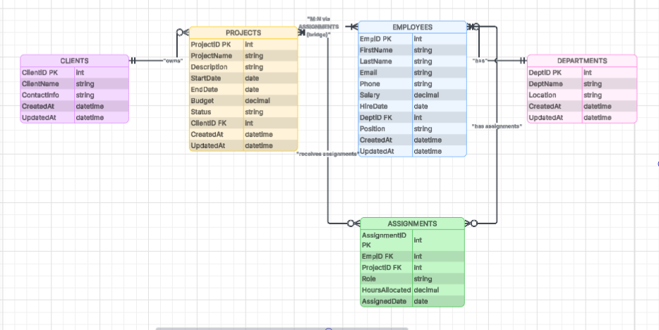

13. Conclusion
This database system, designed and implemented using SQL Server, successfully manages the operations of a tech company.By employing proper relationships, normalization up to 3NF, and bridge tables for complex assignments, it ensures efficient tracking of employees, projects, resource allocation, and client management without data anomalies.

